PIZZAS  11”-$12.50 7”-$9.50  Hand-formed pizzas and calzone’s baked to order in our brick oven with premium meats, cheeses, house made sauce and made from scratch pizza dough  Margherita  Olive oil, fresh basil, sliced tomatoes, mozzarella, salt & black pepper.  Traditional Cheese  Marinara sauce, mozzarella & parmesan.  Four Cheese  Marinara, mozzarella, cheddar, feta & parmesan cheese.  Pepperoni  Marinara, mozzarella & pepperoni.  Italian Sausage  Marinara, mozzarella, Italian sausage, green olives & red onions.  Supreme  Marinara, mozzarella, pepperoni, Italian sausage, bell peppers, red onions & black olives.  The 09’er  Grilled chicken, bacon, marinated onions, mozzarella, rosemary diced tomatoes, sliced avocado and a drizzle of house made ranch.  Hawaiian BBQ  Smokey BBQ sauce, grilled chicken, mozzarella, pineapple, red onions and fresh cilantro.  Chicken Pesto  Basil pesto sauce, grilled chicken, tomato, mozzarella & parmesan cheese  Fajita Chicken  Black Beans, grilled chicken, mozzarella & cheddar cheese. Topped with Pico de Gallo and sour cream.  SHAKES  Reg…… $5.50 Lg……. $6.25  Vanilla, Chocolate, Strawberry, Banana, Chocolate Mocha, Cherry, Butterfinger™, Espresso, Oreo™ Cookie, Peppermint | SANDWICHES  (Served with fries)  Grilled Chicken Sandwich………... $13.50  Grilled chicken breast, lettuce, tomato, onion, pickle mayo & mustard.  Roasted Poblano Chicken……....... $13.75  Grilled chicken breast with roasted poblano peppers, grilled onions, house made chipotle mayo and pepper jack cheese.  Chicken Bean Burger………………. $13.75  A Texas original! Grilled chicken breast, cheddar cheese, house made black beans, Fritos™, onions & picante sauce. Add fresh guacamole …. $1.50  Mushroom & Mozzarella Chicken.... $13.75  Grilled chicken breast, lettuce, tomato, onion, pickle mayo & mustard topped with sautéed mushrooms and mozzarella cheese.  Bacon & Mozzarella Chicken………. $14.25  Grilled chicken breast, lettuce, tomato, onion, pickle mayo & mustard topped mozzarella cheese and bacon.  Chipotle Fish Sandwich ……………. $ 12.00  Fried white fish, chipotle mayo, lettuce, pickle, tomato & pepper jack cheese.  EZ’S Veggie Burger ……………....... $11.75  100% vegetarian patty, lettuce, tomato, onion, pickle mayo & mustard.  Veggie Bean Burger………………. $11.75  A Texas original! 100% vegetarian patty, cheddar cheese, house made black beans, Fritos™, onions & picante sauce. Add fresh guacamole …. $1.50  Veggie Poblano Burger……….…. $11.75  100% vegetarian patty with roasted poblano peppers, grilled onions, house made chipotle mayo and pepper jack cheese.  Greek Veggie Burger……………. $11.75  100% vegetarian patty with basil pesto, black olives, feta cheese, roasted red peppers & mixed greens. | 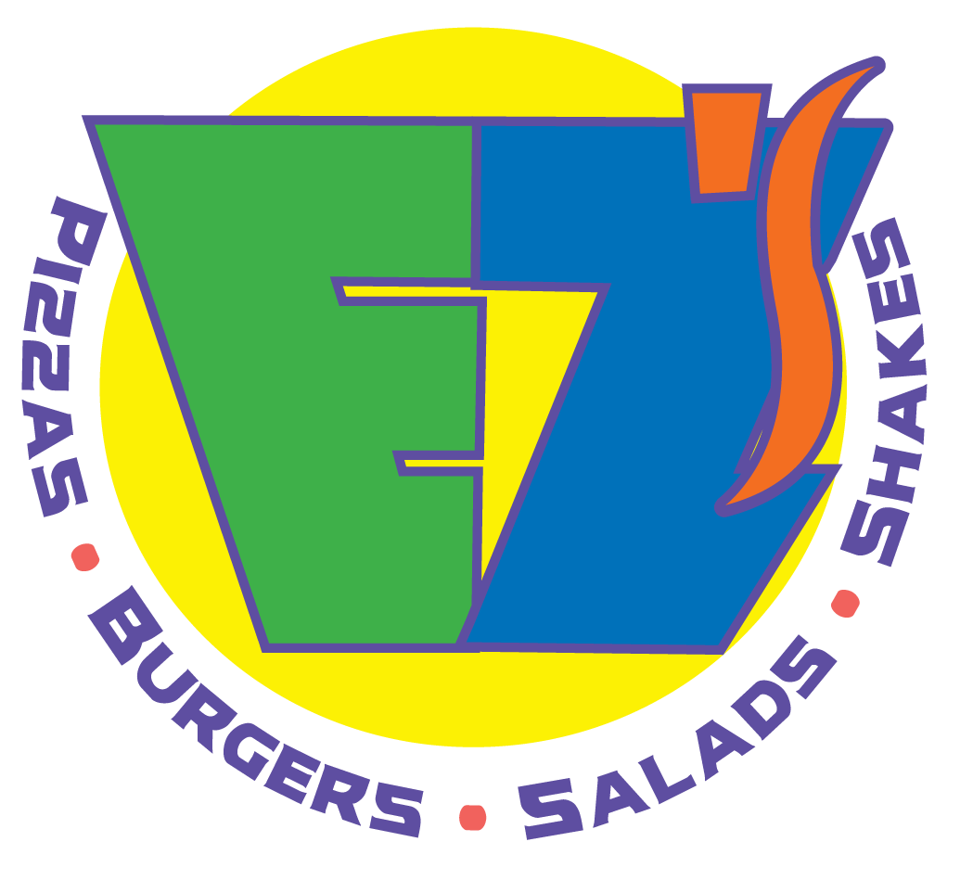  Serving America’s Favorite Foods Since 1989  Alamo Heights:  6498 N New Braunfels Ave  San Antonio, TX 78209  (210) 828-1111  Hwy 281 & Bitters  734 W Bitters Rd  San Antonio, TX 78216  (210) 490-6666  COMING 2025!  Potranco & Tally Rd
SIGNATURE DISHES  Rosemary Chicken  Oven roasted chicken dressed with olive oil and rosemary. Served with rice, steamed veggies and focaccia bread.  ½ Chicken…… $15.00  ¼ Chicken…… $13.00  Basil Chicken Pasta…………….... $12.00  Rotini pasta with grilled chicken, basil pesto sauce, diced tomatoes, parmesan cheese & focaccia bread.  Grilled Rainbow Trout….…….…. $15.25  Grilled rainbow trout, garlic butter, rice, steamed veggies and focaccia bread.  Grilled Salmon………………………. $16.00  Grilled salmon, rice, steamed veggies & focaccia bread.  Chicken Alfredo Pasta.………....$12.00  Rotini pasta, grilled chicken creamy alfredo sauce, parmesan cheese & focaccia bread.  Alamo Bowl ……………………….…..$12.00  Layers of rice, black beans, picante dressing, grilled chicken, cotija cheese and fresh Pico de Gallo. Served with tortilla chips.  Grilled Chicken & Veggie………..$13.50  Grilled chicken breast served with rice, steamed veggies and focaccia bread.  Chicken Tenders .…………………..$12.00  Fried chicken tenderloins with your choice of fries, steamed veggies or rice.  KIDS MENU  All kid’s menu items come with choice of kid’s side  $6.00  Kids Pizza (cheese, pepperoni or sausage)  Hamburger  Cheeseburger  Chicken Tenders  Pasta (rotini pasta with parmesan & marinara sauce) | SALADS & SOUPS  EZ’S Caesar  Romaine lettuce, croutons, chopped egg, parmesan cheese & house made Caesar dressing  Half…… $6.75 Full…… $8.50  Add Chicken…. $2.50  Italian Mixed Greens  Mixed greens, tomato, red onions, green olives & house made balsamic vinaigrette dressing.  Half…… $6.75 Full…… $8.25  Add Chicken…. $2.50  Super Foods Spinach Salad  Spinach, blueberries, toasted pecans, artichoke hearts, feta cheese & house made lemon vinaigrette dressing.  Half…… $7.00 Full…… $11.00  Add Chicken…. $2.50  Add Salmon…. $6.00  Shanghai Asian Salad……………… $11.25  Mixed greens, grilled chicken, shredded carrots, cilantro, green onions, tossed in house made honey lime vinaigrette. Garnished with toasted almonds, Chinese noodles, mandarin oranges & oriental dressing.  Pico Pasta Salad……………...……… $11.25  Romaine lettuce, rotini pasta with black beans, corn, cotija cheese, fresh Pico de Gallo, grilled chicken and house made tomato vinaigrette dressing. Served with red corn tortilla chips.  EZ’S Cobb Salad...……………...…… $13.00  Romaine lettuce, grilled chicken, avocado, egg, bacon, tomatoes, black olives, green onions & house made blue cheese dressing.  Chicken Tortilla Soup  Roasted chicken & vegetable soup with cheddar & mozzarella cheese, fresh avocado, cilantro and tortilla strips.  Cup…… $6.50 Bowl…… $8.25  FOCACCIA BREAD  Reg. $3.00 / Lg. $4.00  Rosemary & Salt  Parmesan & Oregano  Feta & Fresh Basil | BURGERS  (Served with fries)  EZ’S Classic Burger……………………....... $12.75  ½ pound Angus patty, lettuce, tomato, onion, pickle mayo & mustard. Add cheddar cheese…. $0.75  Classic Bacon Cheddar Burger…………. $14.00  ½ pound Angus patty, lettuce, tomato, onion, pickle mayo & mustard topped with cheddar cheese and bacon.  World Famous Bean Burger……………... $13.50  A Texas original! ½ pound Angus patty, cheddar cheese, house made black beans, Fritos™, onions & picante sauce. Add fresh guacamole …. $1.50  Roasted Poblano Burger…….………..…. $13.50  ½ pound Angus patty with roasted poblano peppers, grilled onions, house made chipotle mayo and pepper jack cheese.  Mushroom & Mozzarella Burger……. $13.50  ½ pound Angus patty, lettuce, tomato, onion, pickle mayo & mustard topped with sautéed mushrooms and mozzarella cheese.  Classic Bison Burger………………………. $15.25  Grilled bison patty, lettuce, tomato, onion, pickle mayo & mustard  Colorado Bison Burger…………………...$15.75  Grilled bison patty topped with cheddar cheese and smokey BBQ sauce with house made chipotle mayo, greens, grilled onions, jalapenos and pickles  Turkey Burger…………...…………………...$13.25  A healthy turkey patty with lettuce, tomato, onion, pickle mayo & mustard on a wheat bun.  Chili Cheeseburger……………….………...$13.25  ½ pound Angus patty, onions and topped with chili house made chili and mixed cheese  SIDES  Fries …. $2.95  Sweet Potato Fries…$3.65  Onion Rings…. $3.50  Half & Half ……. $3.75  Cheese Fries  Reg. $5.50 Lg $6.75  Chili Cheese Fries  Reg. $6.50 Lg. $7.25

